**‘AccessBank DBA Internship Program’**

**Project 26: Linked Servers**

**Step 1: Create new SQL Server instance by using setup.exe and configure its name, Aut. Mode and etc.**

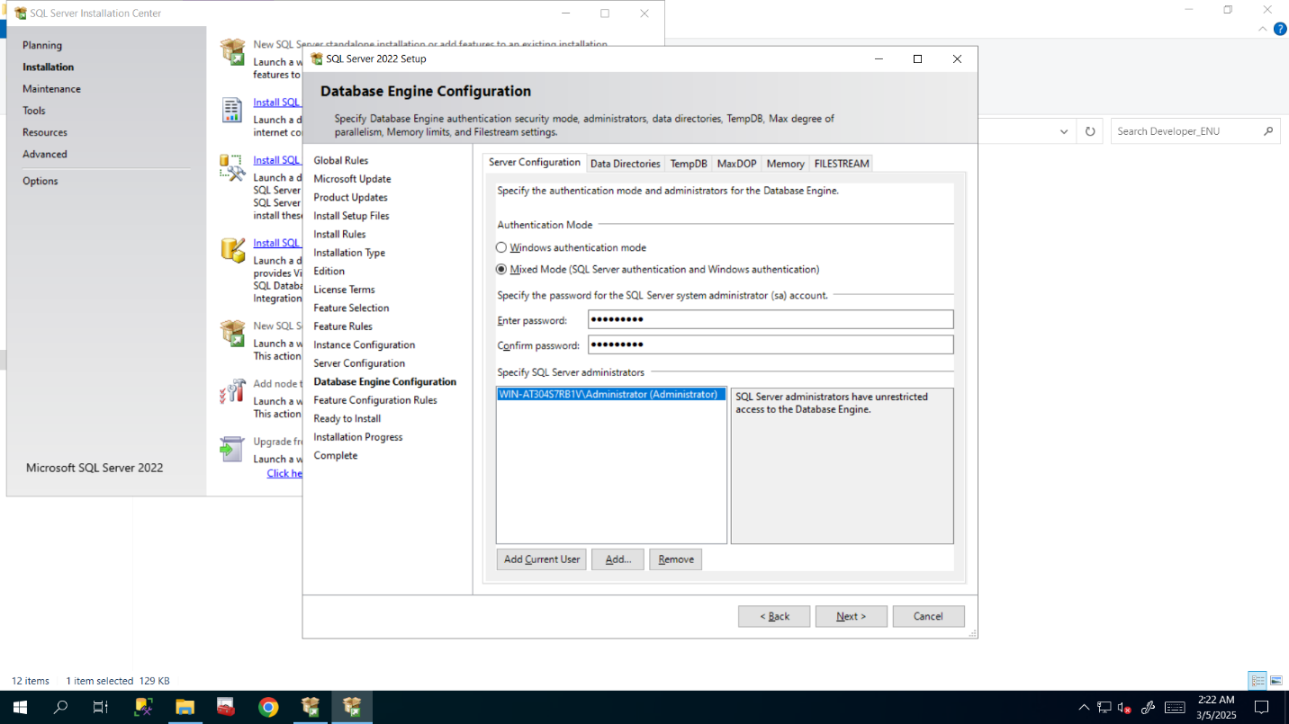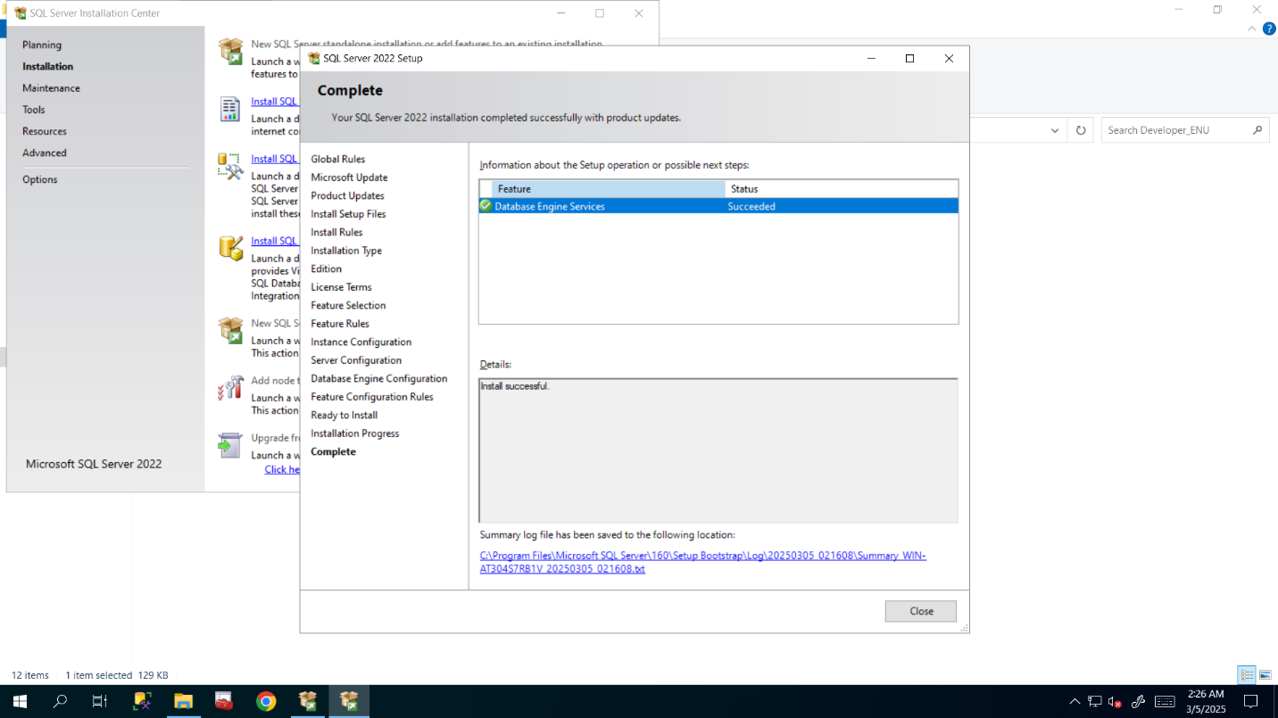

**Step2: Create Linked Server between these two instances**

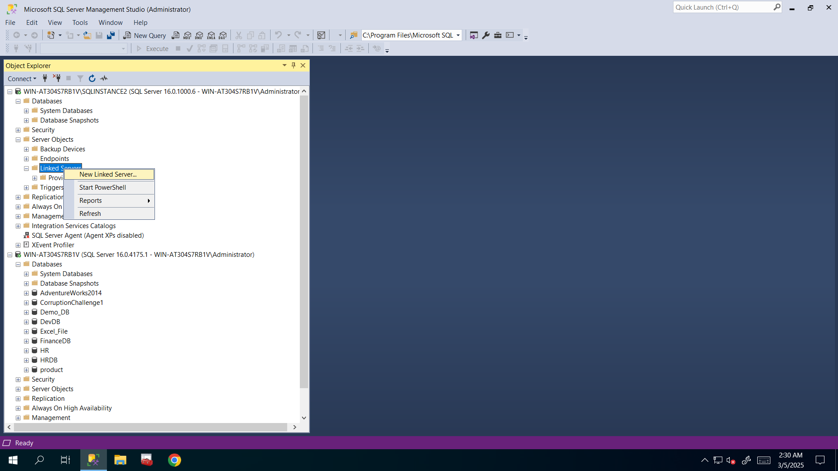

**Step3: Configure its name, server type in General Section and add login in Security Section and impersonate it for logging in and executing queries by using same Windows credentials**

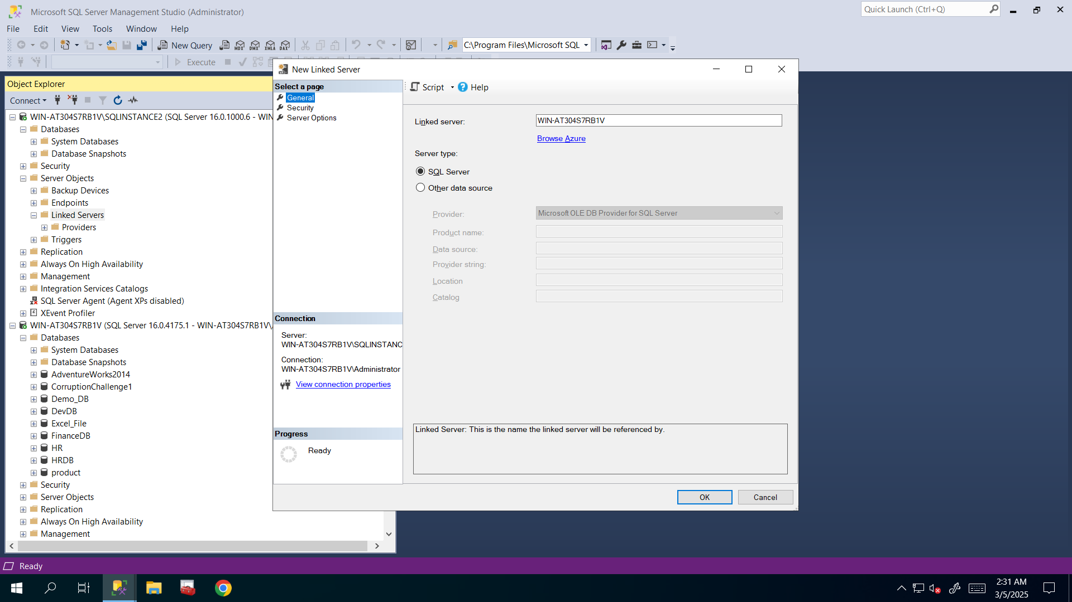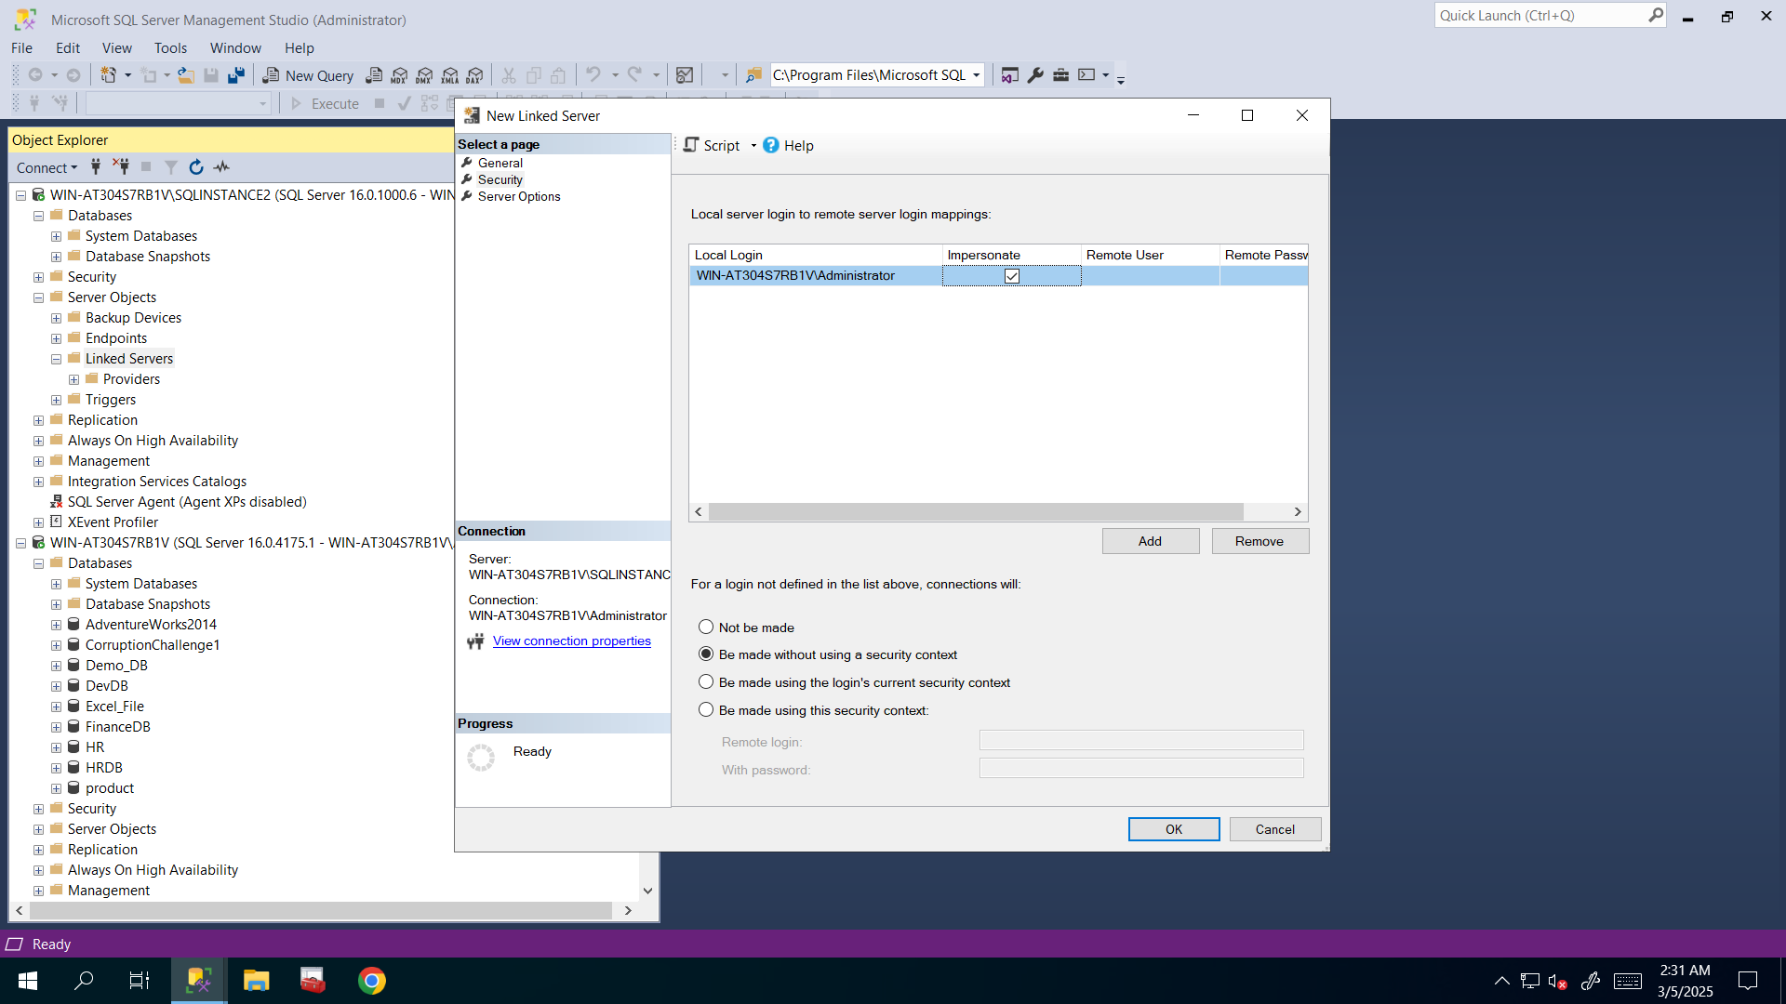

**Step4: Check and test to make sure Linked Server is created successfully and running smoothly and by the way I highlighted Status Bar to show that I executed these queries newly created instance**

